How to change your signature in Outlook Web Access

1. In Outlook, click on the gear icon in the upper right-hand section of the screen. At the bottom of the pop-up side panel, click on **View all Outlook settings**.

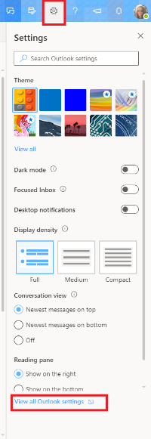

1. In the pop-up window that appears, click on **Mail** in the leftmost menu, and then **Compose and reply** in the menu next to it. Add your signature in the text box at top.

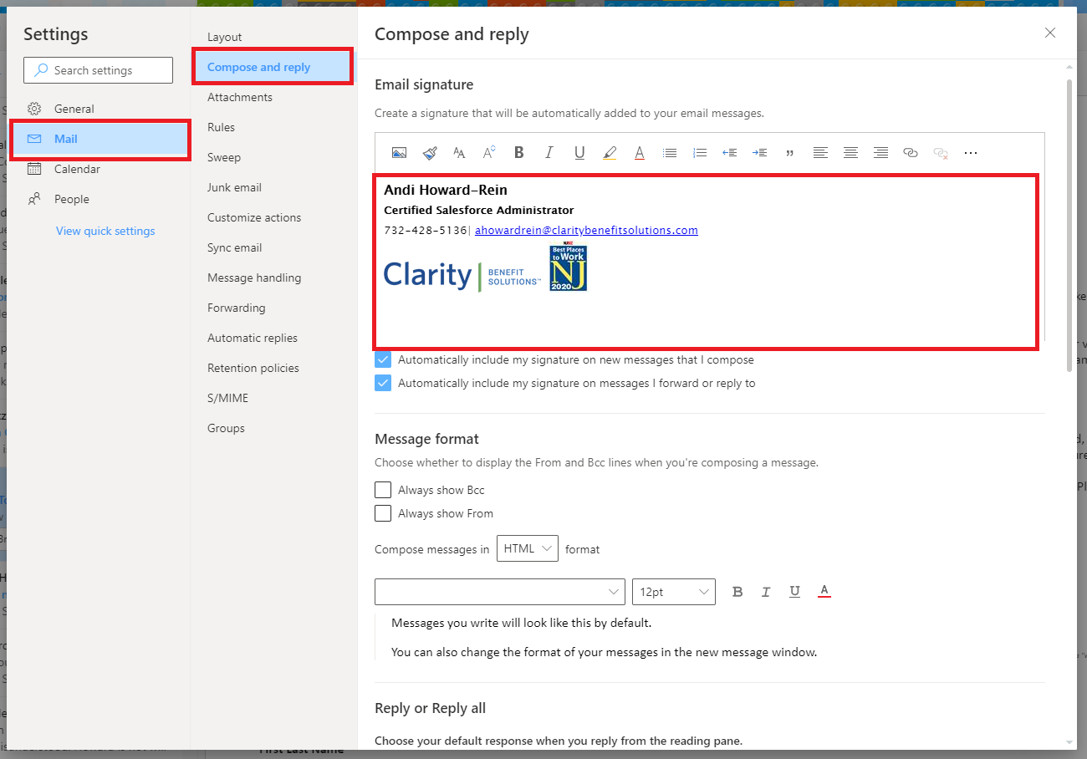

1. To make your email address a link, highlight it, and click on the link icon at the top right of the signature composer box. In the pop-up window that appears, type **mailto:** and then your email address (no spaces) in the **Web address (URL):** box. Click the **OK** button.

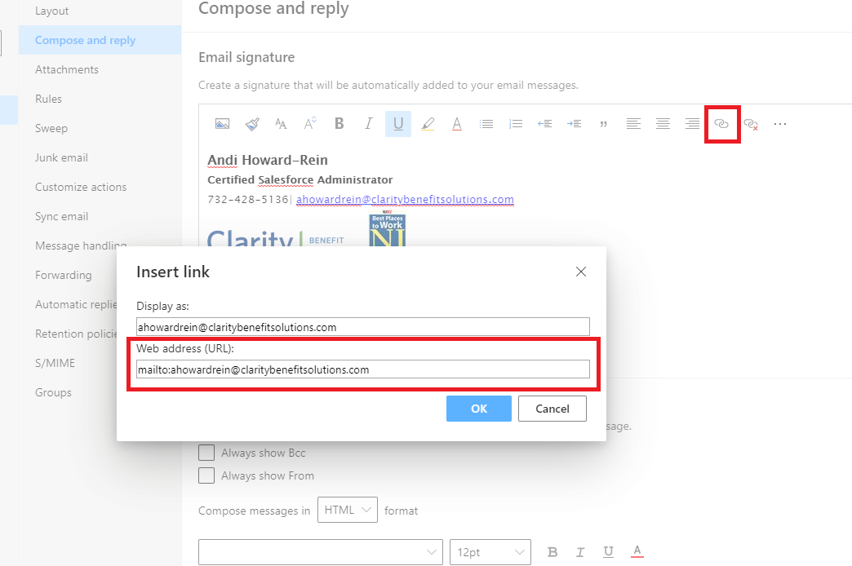

1. Once you are done, click the **Save** button at the bottom of the pop-up window.

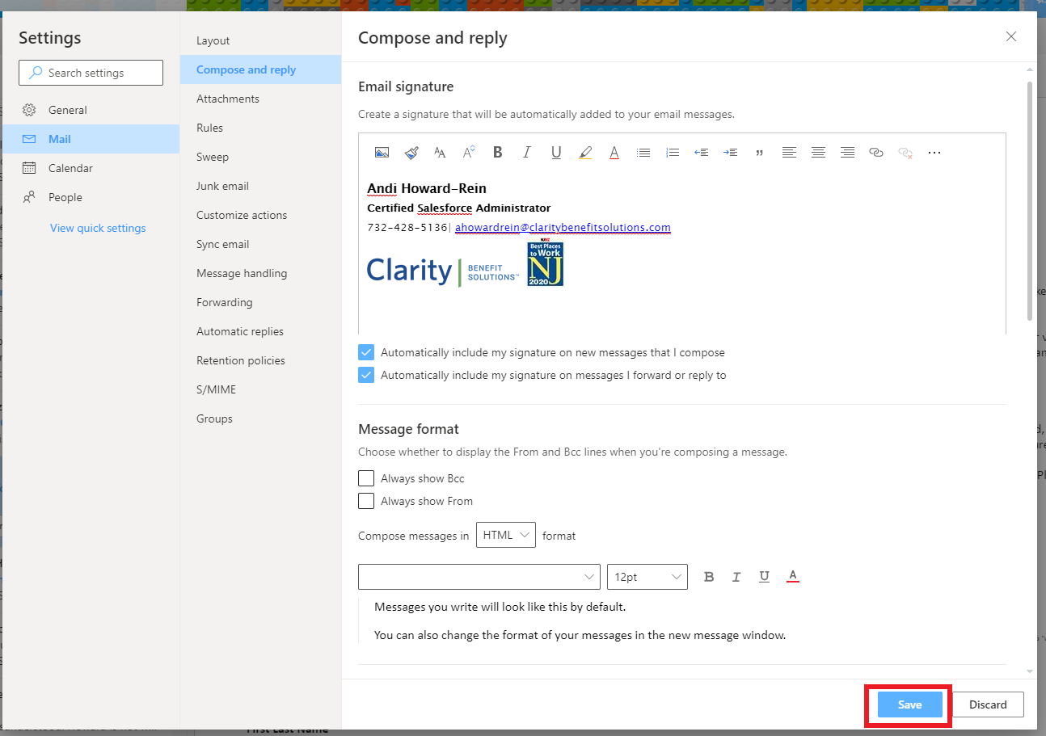

**Note: In order to add images to your signature, you will need to first save them to your Y Drive.