**How to change your signature in Salesforce**

1. Click on your profile picture (or little woodland creature if you haven’t uploaded a profile picture yet) in the top right-hand corner, and click on **Settings**.

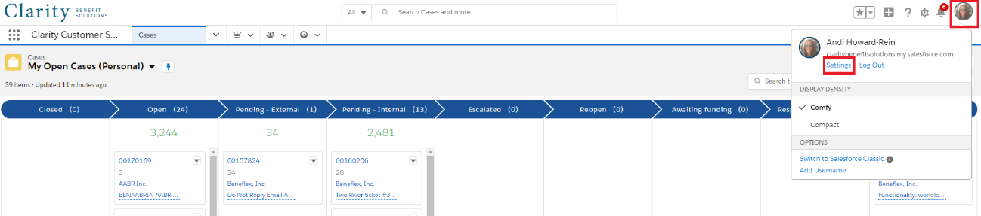

1. On the left-hand menu, click on **Email**, and then **My Email Settings**.

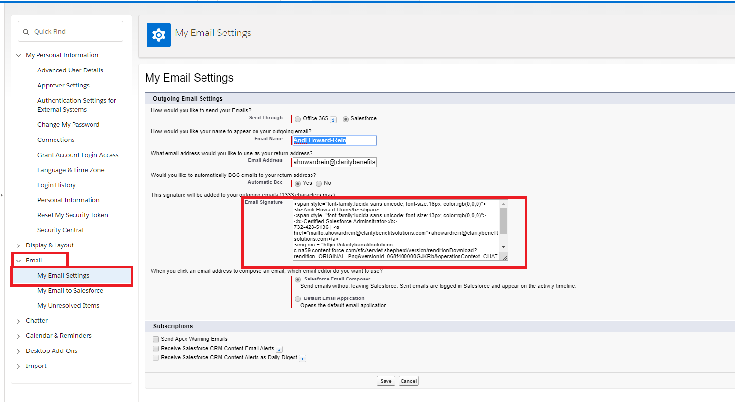

1. In the **Email Signature** text box, delete everything that is there and enter the code from below, replacing the highlighted parts with your information, clicking **Save** when done. Note that the first item highlighted is the URL for your photo. The link for each of your photos is included after the block of code below.

***Pro Tip:*** *Edit fields directly within this word doc and paste the final copy code in SF.*

<p><img src = "https://claritybenefitsolutions--c.na153.content.force.com/servlet/servlet.ImageServer?id=0155G000002MlZe&oid=00Df4000003kFDv&lastMod=1611763603000" ALIGN="left"/><span style="font-family:arial; font-size:12px; color:rgb(35,73,138)"><b> NAME</b>

<span style="color:rgb(59,56,56)"><b> TITLE, DEPARTMENT</b>

<span style="color:rgb(103,156,91)"><b> m: </b></span><span style="color:rgb(59,56,56)">PHONE NUMBER

<span style="color:rgb(103,156,91)"><b> e: </b></span><span style="color:rgb(59,56,56)"><a href="mailto:email@claritybenefitsolutions.com">email@claritybenefitsolutions.com</a>

<span style="color:rgb(59,56,56)"><i> We are <a href="https://vimeo.com/414846774">Simply Smarter</a>

We are a <a href="https://video214.com/play/meshlA8zYtHlEwfmx5uyzw/s/dark">Simply Better</a> fit for our partners</i>

Want to chat? <a href="CALENDLY LINK">Book time with me</a></span>

<img src="https://claritybenefitsolutions--c.na153.content.force.com/servlet/servlet.ImageServer?id=0155G000002MlY2&oid=00Df4000003kFDv&lastMod=1611682861000"/></p>

**List of photos and URLs**

Christine: <https://claritybenefitsolutions--c.na153.content.force.com/servlet/servlet.ImageServer?id=0155G000002MlZe&oid=00Df4000003kFDv&lastMod=1611763603000>

Becky: <https://claritybenefitsolutions--c.na153.content.force.com/servlet/servlet.ImageServer?id=0155G000002MmIF&oid=00Df4000003kFDv&lastMod=1611766070000>

Bethany: <https://claritybenefitsolutions--c.na153.content.force.com/servlet/servlet.ImageServer?id=0155G000002MmIP&oid=00Df4000003kFDv&lastMod=1611766095000>

Bill S: <https://claritybenefitsolutions--c.na153.content.force.com/servlet/servlet.ImageServer?id=0155G000002MmIe&oid=00Df4000003kFDv&lastMod=1611766122000>

Chancy: <https://claritybenefitsolutions--c.na153.content.force.com/servlet/servlet.ImageServer?id=0155G000002MmIo&oid=00Df4000003kFDv&lastMod=1611766162000>

Dave: <https://claritybenefitsolutions--c.na153.content.force.com/servlet/servlet.ImageServer?id=0155G000002MmIt&oid=00Df4000003kFDv&lastMod=1611766187000>

Eddie: <https://claritybenefitsolutions--c.na153.content.force.com/servlet/servlet.ImageServer?id=0155G000002MmIy&oid=00Df4000003kFDv&lastMod=1611766204000>

Liz: <https://claritybenefitsolutions--c.na153.content.force.com/servlet/servlet.ImageServer?id=0155G000002MmJD&oid=00Df4000003kFDv&lastMod=1611766278000>

Krista: <https://claritybenefitsolutions--c.na153.content.force.com/servlet/servlet.ImageServer?id=0155G000002MmJ3&oid=00Df4000003kFDv&lastMod=1611766303000>